**Reference: DOP & T O.M. No. 11013/2/2014-Estt. A.111 dated February 2,2015**

**Annual Return on cases of Sexual Harassment**

**Period: 1st April, 2024 to 31st March, 2025**

**Name of the university: Dr. Ambedkar College, Deeksha Bhoomi, Nagpur,**

**Rashtrasanta tukdoji Maharaj Nagpur University, Nagpur.**

|  |  |  |
| --- | --- | --- |
| Sr. No. |  | Number of Cases* |
| 1. | Number of Complaints of sexual harassment received in the year. | -Nil- |
| 2. | Number of Complaints disposed off during the year | N A |
| 3. | Number of cases pending for more than 90 days. | N A |
| 4. | Number of Workshops on awareness programmes against sexual harassment conducted during the year | 03 |
| 35. | Nature of action. | N A |

Note:

* Information is to be provided in consolidated form in respect of University as a whole (including affiliated/constituent colleges).
* **Detail Report of the Programme attached herewith for your kind perusal.**

 

**Principal Co-ordinator- ICC**

**Dr.Mrs. B.A. Mehere Dr. Mrs. S. P. Kalamdhad**

1. **DR. AMBEDKAR COLLEGE, DEEKSHA BHOOMI, NAGPUR**

**INTERNAL COMPLAINTS COMMITTEE**

**Date: 30th August 2024**

**Name of the Programme: Lecture on “Prevention of sexual Harassment from the perspective of law and Society”**

**Resource Persons: Dr. Chinmayee Nimkhedkar**

**Organised by: Internal Complaints Committee (ICC) Cell**

**Name of Program Co-ordinator: Dr. Sandhya Kalamdhad**

**Number of Attendees: Around 100**

**Venue: Seminar hall, Department of Law, Dr. Ambedkar College, Deekshabhoomi, Nagpur**

**NOTICE**

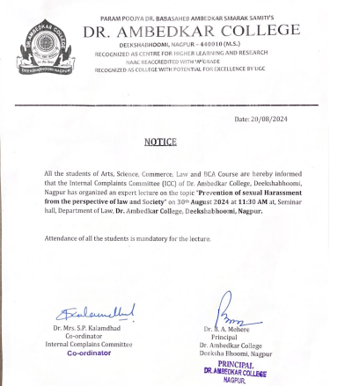

**REPORT ON GUEST LECTURE**

Sexual harassment is a serious manifestation of sex discrimination at the workplace and a violation of human rights as well as fundamental rights, enshrined in the Constitution of India. It is yet another form of violence against women reflecting patriarchal mind sets and gender based discrimination that women experience at work. It is also a manifestation of power relations, as women are much more likely to be the victims of sexual harassment because of their already existing vulnerability, insecurity, and social conditioning to accept discrimination in silence. Hence, there is a strong need to strengthen the Sexual Harassment Act. To make the legislation more effective, the need is to publicise this law to the people so that it would make its protection more comprehensive and effective. With this aim The Internal Complaints Committee on Sexual Harassment at the Workplace arranged oe lecture for the Gender Rights, titled, “topic “**Prevention of sexual Harassment from the perspective of law and Society**” on **30th August 2024** at **11:30 AM** at, Seminar hall, Department of Law, **Dr. Ambedkar College, Deekshabhoomi, Nagpur.**

The response to the workshop was overwhelming. **Around 100 students, 07 faculties and 05 non- teaching staff attended the lecture.** The aim of this lecture was to empower women faculty, non-teaching staff and students and provide protection against sexual harassment and offer the right to work with dignity and non-discrimination, based on the Human Rights treaties and the ratification of International Conventions by the Indian Government. Hence, with the ultimate object as, to strengthen the implementation of Sexual Harassment Act and to make its protection more comprehensive and effective.

**Dr. Chinmayee Nimkhedkar** in her address threw light on the patriarchal domination that is deeply rooted in the Indian Society. This Patriarchy, she said, emanates from the sex-based division of labour that relegated the woman’s role essentially within the four walls of the house, and the prerogative to work and earn money came to be considered the man’s world. This gave birth to hierarchy between man and woman and gave a subordinate position to women, who is subject to man’s power. This subordination has given birth, among others to the prevalence of sexual harassment of women.

She drew attention of the audience towards the role played by the Prevention of Sexual Harassment Act enacted by the State. The role played by such laws is immense, but she pointed out that law has its own limitations. She further explained all the provisions of Law along with latest case laws.

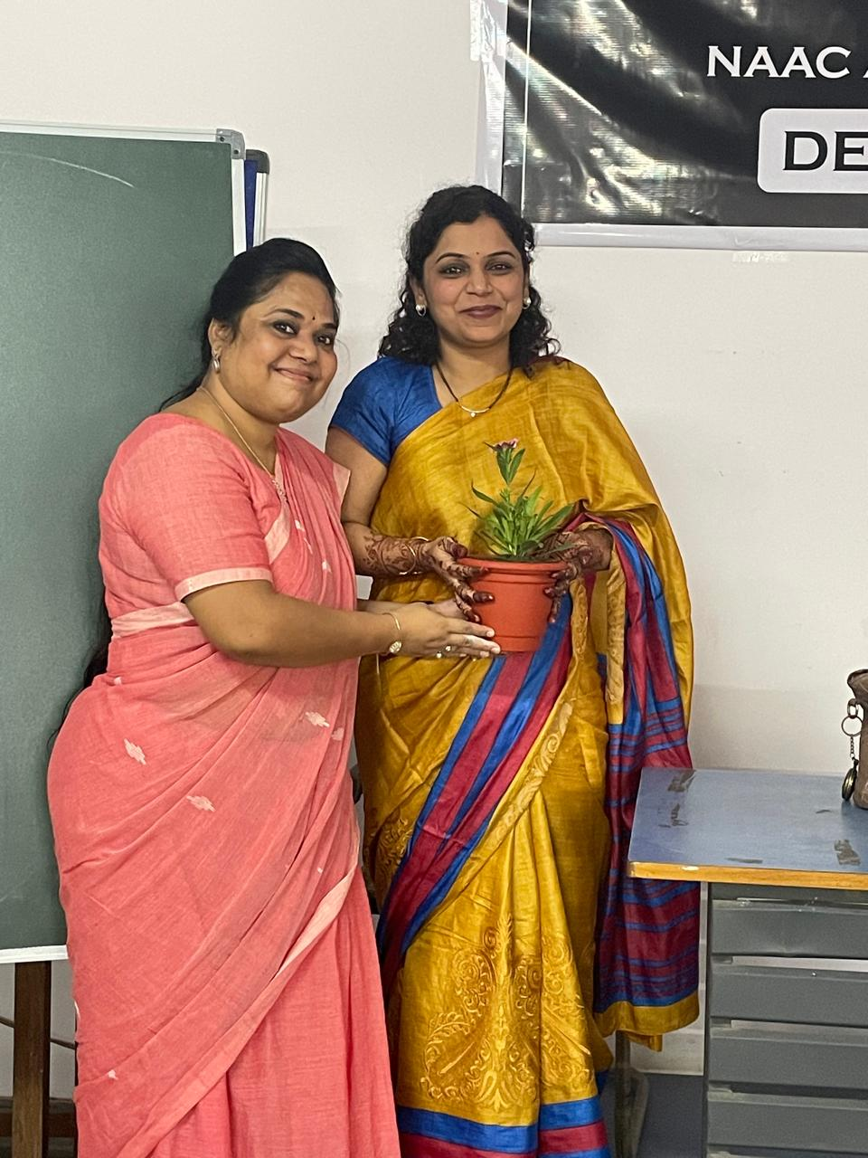

(Dr.P. R. Lokhande, Associate Professor of the college welcoming the guest speaker)

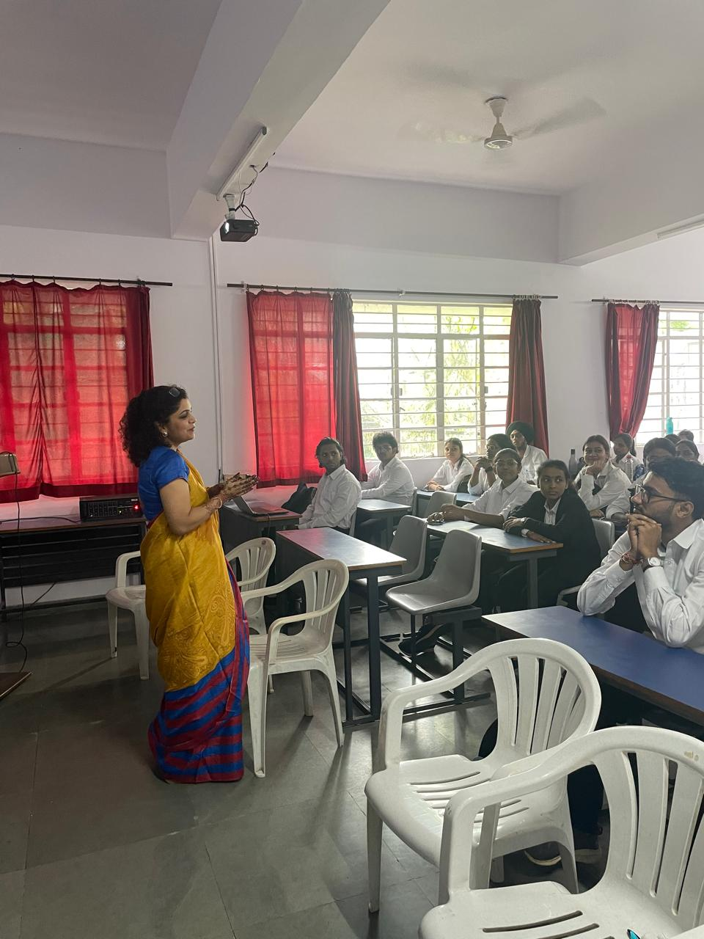

(**Dr. Chinmayee Nimkhedkar** delivering the lecture)

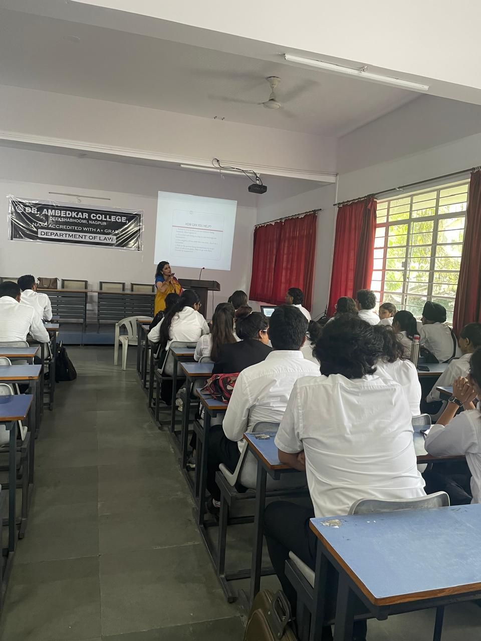

(Audience Present at the Programme)

**2. DR. AMBEDKAR COLLEGE, DEEKSHA BHOOMI, NAGPUR**

**INTERNAL COMPLAINTS COMMITTEE**

**Date: 19th Sept 2024**

**Name of the Programme: Lecture on “Prevention of Sexual Harassment at Higher Educational Institution: A Discourse”**

**Resource Persons: Dr. Shalini Lihitkar**

**Organised by: Internal Complaints Committee (ICC) Cell**

**Name of Program Co-ordinator: Dr. Sandhya Kalamdhad**

**Number of Attendees: Around 150**

**NOTICE**

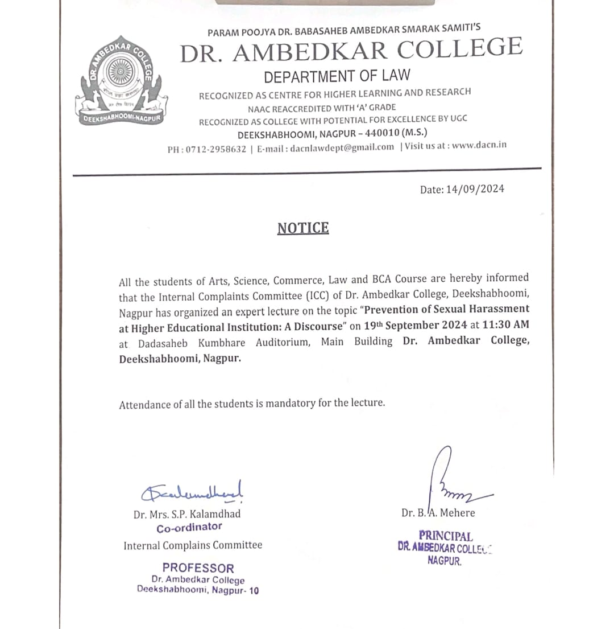

**REPORT ON GUEST LECTURE**

The**Internal Complaints Committee Cell** of Dr.Ambedkar College, Deekshabhoomi Nagpur, has organised a Guest Lecture on **19th Sept 2024** for the students of Arts, Science, Commerce, Law and BCA of the college on the topic “**Prevention of Sexual Harassment at Higher Educational Institution: A Discourse”**

Around **150** attendees were present in the program. **Dr. Shalini Lihitkar, Professor and Head, Department of Library, RTMNU Nagpur** invited as guest speaker in the program. **Dr.B.A. Mehere,** Principal of the college gave brief information regarding the topic of the lecture along with the welcome address.

**Dr. Shalini Lihitkar** commenced the lecture by Darwin’s Theory of Natural selection which is based on three Principals namely, Inheritance, Overproduction and Survival of Fittest. She emphasized that the roots of provision of sexual harassment lies in the constitution of India. She empathetically asked the audience about their relation with parents, who are the first one who address the issues faced by children.

Through her commendable talk she appealed the students to first understand that we need to respect the woman. In furtherance to this she vividly explained the student’s different forms of Sexual harassment and defined the same with different examples. She elaborately explained how the women are victimised and discriminated since long time. She further briefly narrated the significant and leading cases and the international convention on sexual harassment. He explained the real-life concerned cases, complaint mechanism, conciliation provisions almost all the provisions of 2013 Act on sexual Harassment.

The lecture is followed by the question-and-answer session wherein the different students asked the variety of questions which has been nicely answered by the guest speaker with full satisfaction of the students. She ended his talk by again appealing the students to be sensitive, respectful and be responsible towards the women.

The members of Internal Complaints Committee have graced the event by their presence. The Programme was conducted and concluded by Ms. Sanika Durugkar a student a Law 5 Year course.

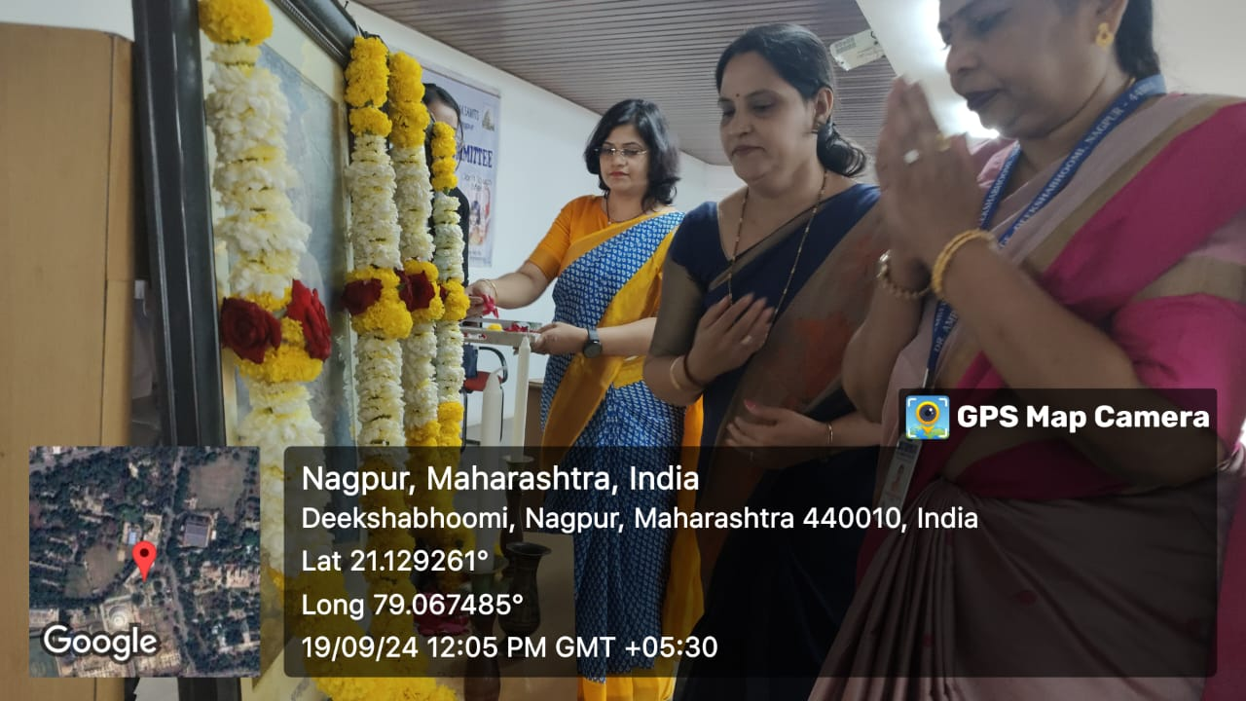

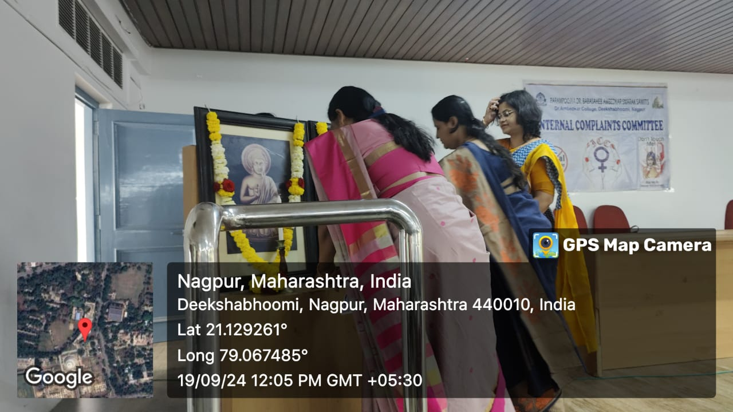

(Dignitaries seeking blessings of Tathagat Bhagwan Gautam Buddha and Dr. Babasaheb Ambedkar)

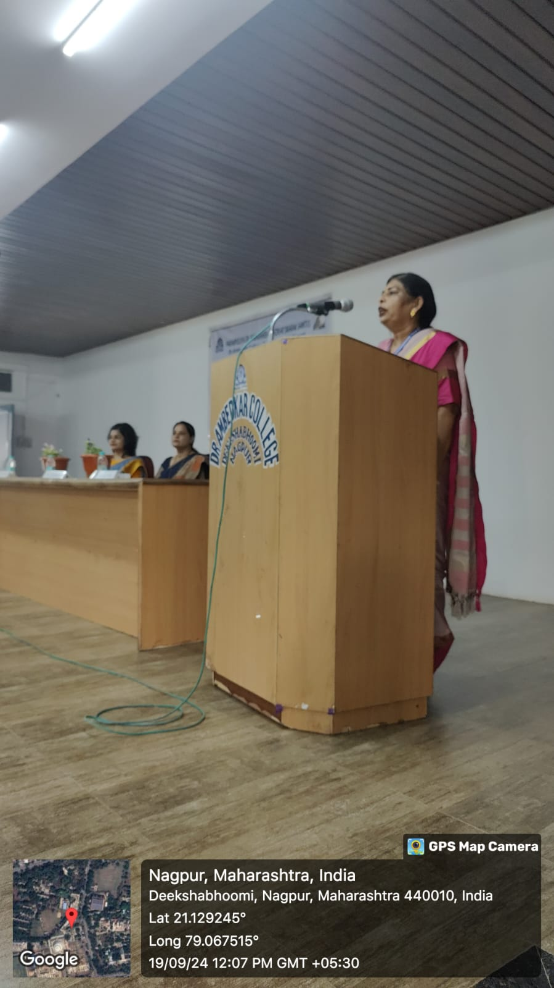

(Dr.B.A. Mehere, Principal of the college giving the introductory remark and welcome address)

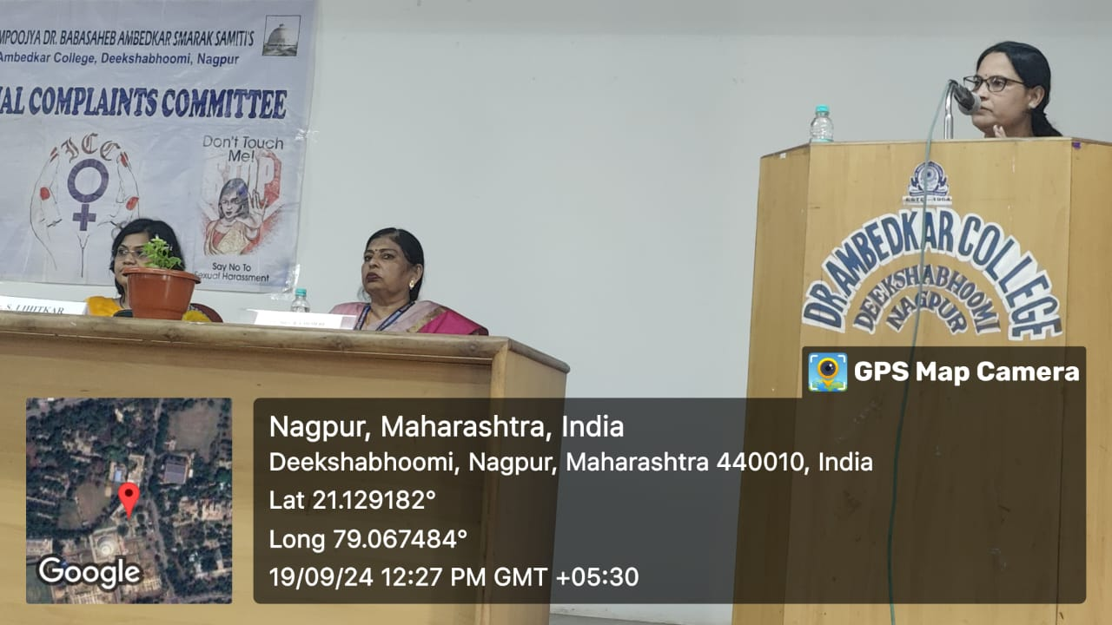

(**Dr. Shalini Lihitkar** delivering the lecture)

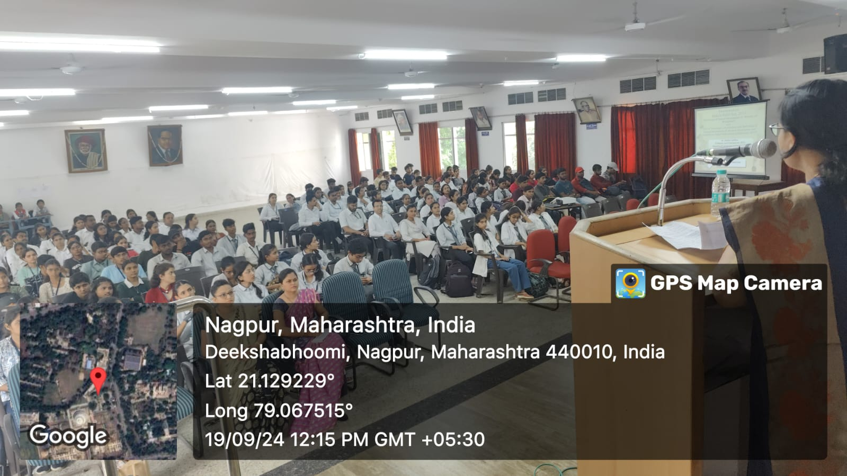

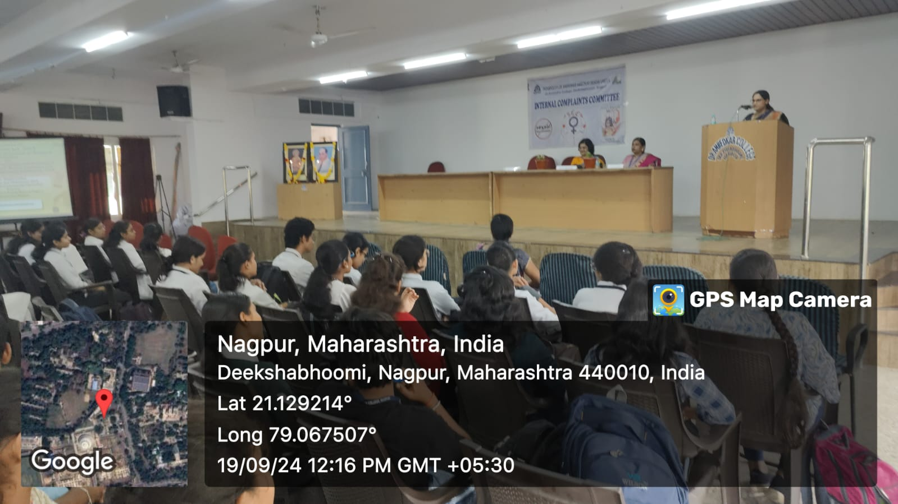

(Audience Present at the Programme)

**3. WORKSHOP ATTENDED BY MEMBERS OF ICC -23-24**

